Q1.

Code:

package Q_01;  
public class Q1 {  
 public static void main(String[] args) {  
 int A=10;  
 int B=20;  
 int C=30;  
 int X=40;  
 int Y=50;  
 int r=7;  
 double result1=Math.*sqrt*(Math.*pow*(B,2)+4*A*C);  
 double result2=Math.*sqrt*(X+4*Math.*pow*(Y,3));  
 double result3=Math.*cbrt*(X*Y);  
 double area=Math.*PI*\*Math.*pow*(r,2);  
 System.*out*.println(result1 + " " + result2 + " " + result3 + " " + area );

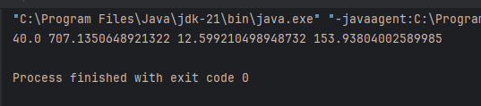Output:

Q2.

Code:

package Q_02;  
import java.util.Scanner;  
public class Q2 {  
 public static void main(String[] args) {  
 Scanner scan=new Scanner(System.*in*);  
 System.*out*.println("enter values in centimeters");  
 int value= scan.nextInt();  
 float outputInches= (float) (value/2.54);  
 float outputFeet=outputInches/12;  
 System.*out*.println(outputInches + " " + outputFeet);  
 }  
}

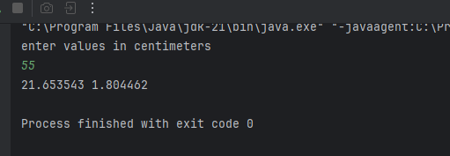Output:

Q3.

Code:

package Q_03;  
import java.util.Scanner;  
public class Q3 {  
 public static void main(String[] args) {  
 Scanner scan=new Scanner(System.*in*);  
 System.*out*.println(" Inputs temperature in degrees Celsius: ");  
 int celsius= scan.nextInt();  
 double output=1.8*celsius + 32;  
 System.*out*.println("Degrees Fahrenheit: "+output);  
  
 }  
}

Output:

Q4.

Code:

package Q_04;  
import java.util.Scanner;  
public class Q4 {  
 public static void main(String[] args) {  
 Scanner scan=new Scanner(System.*in*);  
 System.*out*.println("Enter the weight in kg: ");  
 int weight=scan.nextInt();  
 float weightP= (float) (weight*2.2);  
 float calories=weightP*19;  
 System.*out*.println(calories);  
  
 }  
}

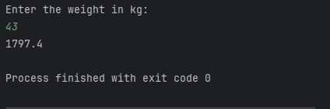Output:

Q5.

Code:

package Q_05;  
import java.util.Scanner;  
public class Q5 {  
 public static void main(String[] args) {  
 Scanner scan=new Scanner(System.*in*);  
 System.*out*.println("input temperature in degrees Fahrenheit");  
 double fahrenheit =scan.nextDouble();  
 double celsius=(fahrenheit-32) * 5/9;  
 System.*out*.println(celsius); }  
}

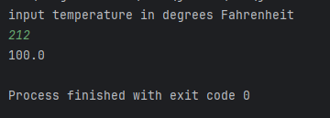Output:

Q6.

Code:

import java.text.SimpleDateFormat;  
import java.util.Date;  
import java.util.Scanner;  
  
public class Q6 {  
 public static void main(String[] args) {  
 Scanner scan=new Scanner(System.*in*);  
 System.*out*.println("Born year: ");  
 int bornYear= scan.nextInt();  
 Date date=new Date();  
 SimpleDateFormat sdf=new SimpleDateFormat("yyyy");  
 int age= Integer.*parseInt*(sdf.format(date))-bornYear;  
 System.*out*.println("You were born in "+ bornYear+" " +"and will be (are)"+" " + age+ " " +"this year");  
  
 }  
}

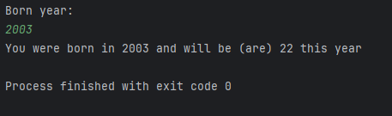Output:

Q7.

Code:

package Q_07;  
  
import java.util.Scanner;  
public class Q7 {  
 public static void main(String[] args) {  
 Scanner scan=new Scanner(System.*in*);  
 System.*out*.println("Enter weight in kg: ");  
 int weight=scan.nextInt();  
 System.*out*.println("Enter height in cm: ");  
 int height= scan.nextInt();  
 Double BMI= (Double) (weight/Math.*pow*((height/100.0),2));  
 System.*out*.println(BMI);  
 }  
}

Output:

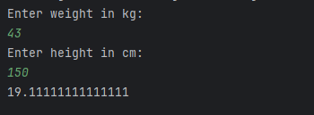

Q8.

Code:

package Q_08;  
import java.util.Scanner;  
public class Q8 {  
 public static void main(String[] args) {  
 Scanner scan=new Scanner(System.*in*);  
 System.*out*.println("Input the radius: ");  
 int radius= scan.nextInt();  
 double volume= (4.0/3)*(Math.*PI*\*Math.*pow*(radius,3));  
 System.*out*.println("volume of a sphere is: " + volume);}}  
 Output:  
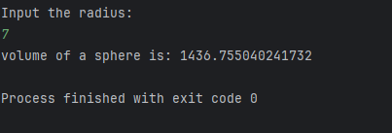

Q9.

Code:

package Q_09;  
import java.util.Scanner;  
public class Q9 {  
 public static void main(String[] args) {  
 Scanner scan=new Scanner(System.*in*);  
 System.*out*.println("invest dollars: ");  
 double P= scan.nextDouble();  
 System.*out*.println("Enter Percentage: ");  
 double R= scan.nextDouble();  
 System.*out*.println("How many years: ");  
 int N= scan.nextInt();  
 double amount=P*(1+Math.*pow*((R/100),N));  
 System.*out*.println("Amount is: "+amount);  
 }  
}

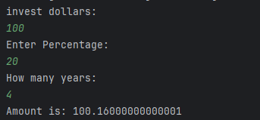Output:

Q10.

Code:

package Q_10;  
  
import java.util.Scanner;  
public class Q10 {  
 public static void main(String[] args) {  
 final int MONTHS_IN_YEAR = 12;  
 Scanner scan=new Scanner(System.*in*);  
 System.*out*.println("Input the loan amount: ");  
 double loanAmount= scan.nextDouble();  
 System.*out*.println("Input the annual interest rate: ");  
 double annualInterestRate= scan.nextDouble();  
 System.*out*.println("Input the loan period: ");  
 int loanPeriod= scan.nextInt();  
 double monthlyInterestRate=annualInterestRate/100.0/MONTHS_IN_YEAR;  
 double numberOfPayments=loanPeriod*MONTHS_IN_YEAR;  
 double monthlyPayment= (loanAmount * monthlyInterestRate) / (1 - Math.*pow*(  
 1 /(1 + monthlyInterestRate), numberOfPayments) );  
 double totalPayment= monthlyPayment * numberOfPayments;  
 System.*out*.println("Monthly and Total payments: "+monthlyPayment + " " + totalPayment);  
 }  
}

Output:

